Media Release
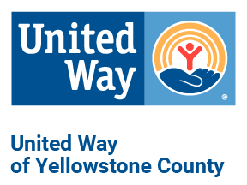
United Way of Yellowstone County Hosts Annual Operation School Supply Drive
MEDIA CONTACT
Kelsie Verlin
406.272.8504
campaign@uwyellowstone.org
www.uwyellowstone.org
Operation School Supply is the annual collection drive hosted by United Way of Yellowstone County (UWYC) to ensure students have access to school supplies all school year. Drives are being held in both Billings and Laurel to benefit the schools and the students.

UWYC’s supply drive is unique in that it provides the opportunity for schools to access the collected supplies year round. Supplies collected from the drive are stored and schools’ are able to use the extra collected supplies as their students need them. The need for school supplies isn’t just essential during the beginning of the year, but throughout. Ensuring students have the tools they need increases the likelihood they will be successful all year long giving them the best chance at learning.
If you or your company or organization would like to host a drive, please contact Chrissy at volcoord@uwyellowstone.org. The final drop off will be on Thursday, September 15 at the United Way offices, 2173 Overland Ave. If you’d like to learn more, see a supplies needed list, or make a monetary donation, please visit: https://www.unitedwayyellowstone.org/operation-school-supply-2022 .

###

