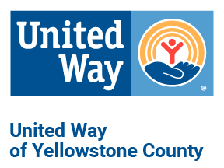
MEDIA RELEASE

Single Working Mother Receives
Gift of Transportation through
Underriner Motors Car Giveaway
MEDIA CONTACT
Billings, MT – December 17, 2021:

On December 21 at 9:30am, one local family will receive the gift of transportation thanks to United Way of Yellowstone County partner Underriner Motors.

Thanks to Bill and Mary Underriner, Blake Underriner, and Underriner Motors employees, Jessica and her family will receive a gently-used car for Christmas. Jessica is a single mother of three children who works hard to support her family, however the lack of a reliable vehicle creates a major challenge to her success. Jessica’s last car was totaled after hitting a deer, causing her to struggle to find transportation for the past year. She commutes 24 miles daily to work, daycare, school, and more. Receiving this vehicle will be life changing for Jessica and her family as it will not only allow her to maintain employment, but will also give them the freedom of dependable transportation to participate in daily events and activities, join groups, and visit friends.

The vehicle is the tenth such gift that the Underriner Motors have given away. “Transportation is a key component to financial stability and career success,” says United Way of Yellowstone County President and CEO, Kim Lewis. “Working with community partners and donors such as Underriner Motors improves our community and provides incredible relief for families in need.”

United Way’s local non-profit partners were invited to submit nominations to United Way for potential candidates in need of transportation. United Way vetted the applications for eligibility and need. Underriner Motors employees made the final decision on the recipient and dedicated their personal time and money to assuring that the gently-used car is safe and reliable.

The vehicle will be presented and given by Bill, Mary, and Blake Underriner, as well as Underriner Motors employees, at the Honda dealership, 3643 Pierce Pkwy, at 9:30am on Tuesday, December 21.

For more information, contact Rachel Pennington, Communications and Marketing Coordinator, at 406.272.8504 or by email at marketing@uwyellowstone.org.

####

