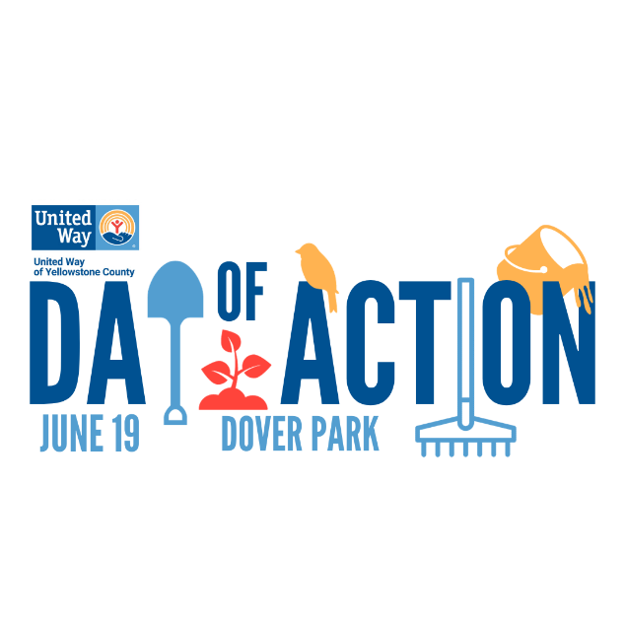

Day of Action 2024
Volunteer Team Coordinator Guide

Day of Action is United Way’s annual community-wide volunteer mobilization effort. This year’s project will take place the afternoon of Wednesday, June 19th at Dover Park in Partnership with Yellowstone River Parks Association.
Volunteering offers numerous benefits, from improving mental health to fostering a sense of community. By connecting with nature and working together on meaningful projects, we can make a lasting impact on both our environment and ourselves.
Your participation is crucial in making this day a success. Together, we can create a positive change in our community and enjoy the benefits of giving back while embracing the great outdoors.

IMPORTANT DATES
May 22- June 14 | Sign-ups begin
June 13 | Team leader training (11:00 am – 11:30 am)
June 19 | Day of Action 2024 (1:00pm – 4 :30pm)
June 19 | Attend the after party at Tiny’s Tavern (5:00 pm – 7:00 pm
June 26 | Alternate date due to weather

Day of Action Schedule
- 1:00pm Check in & Orientation at All American Pharmaceutical parking lot at 2376 Main Street.Park by the zone color you are participating in.
- Have your team members check in with provided QR code.
- 1:30pm Carpool to assigned project area at Dover Park
- 2:00pm – 4:00pm project
- 4:00pm Clean-up project site
- 4:30pm Carpool back to parking lot
- 5:00pm – 7:00pm Tiny’s Tavern will be hosting a complimentary after-party, providing heavy appetizers and snacks for all participants. Tiny’s is located at 323 N. 24th Street. Join us to network and celebrate our efforts of the day!
- Reminders:

- Please ensure that the number of volunteers you registered for Day of Action is the same number of volunteers who show up at the project site on June 19.
- Info on LIVE UNITED Brewery Bingo

Volunteer Team Coordinator Checklist
Day of Action 2024

Day of Action Eligibility Requirements
- The Day of Action Volunteer Team Coordinator is the primary point of contact for United Way staff and will be in charge of all required materials to submit on time.
- The Day of Action Volunteer Team Coordinator must create a YouCanVolunteer.org User Account in order to sign up for Day of Action 2024.
Once registered:
- Designate a Volunteer Team Coordinator Leader.
- Sign-up team members by inviting them to join your team with the link provided. Do not add them yourself; just copy the link to your members to sign-up.
Waiver will be signed at check-in this year. A code will be in your backpack.
- Ensure that all volunteer team members understand the tasks they will perform on Day of Action.

JOB LEADER DESCRIPTION

Duties/ Major Tasks
- Attend team leader orientation June 13, 2023 from 11:00am – 11:30am
- Pick up team leader packet on June 17th from 8 am – 3pm.
- On day of, relay pertinent project information to team members and ensure they park by their zone color flag.
- Make sure team members check-in and sign waiver with QR code provided in packet or sign paper copy also in packet.
- If attending after party at Tiny’s Tavern hand out writstbands to team members so they can enjoy some appetizers and snacks.
- We will provide a master list of your volunteers, and incident report forms just in case of an accident.
- Coordinate how to get your team to your project, this may include carpooling

Benefits for all participants
- Will receive a pair of work gloves
- Snack and water provided (Altana ice-cream)
- Mental and physical health well-being
- Team building with team (conversation card provided)
- Hosted snacks at Tiny’s Tavern after party

Why should I participate?
- Have fun!
- Increase visibility and knowledge about United Way
- Lend muscle to make a lasting, visible difference in our community
- Day of Action isn’t just an event. Rather, it is a vehicle to introduce United Way as a change-maker intended to rally the community for ongoing, sustained action.

Please remember to give acknowledgement to United Way of Yellowstone County and YRPA when referencing Day of Action in any printed media, social media, or interviews!

