**2025-2028 UWYC United to Solve Homelessness**

**Community Housing Navigators**

**Request for Proposals**

**2025-2028 UWYC United to Solve Homelessness**

**Community Housing Navigators**

**Request for Proposals**

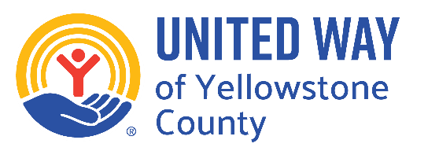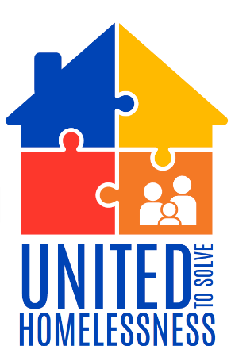

**2025-2028 UWYC United to Solve Homelessness,**

**Community Housing Navigators**

**Request for Proposals**

**Funding Overview**

|  |  |
| --- | --- |
| **Award Amount** | Up to $75,000 annually (for each CHN’s salary, admin & fringe) |
| **Funding Period** | Over 3 Years: July 1, 2025 - June 30, 2028 |
| **Application Deadline** | May 2, 2025 |
| **Award Notification Start Date** | June 2, 2025 |
| **Payment Schedule** | CHN salary, admin and fringe will be allocated in full annually in July. |

**Who Can Apply**

|  |  |
| --- | --- |
| **Agency Type** | 501(c)3 charity or government entity. |
| **Data Management Participant** | Must currently have access to or be able to attain access and utilize the Homeless Management Information System (HMIS) and the Coordinated Entry System (CES). |
| **Geographic Location** | Must operate in part or entirely within Yellowstone County. |

**Key Dates & Process**

|  |  |
| --- | --- |
| **RFP Release & Applications Open** | April 7, 2025 |
| **RFP FAQ Session** | April 8, 2025 |
| **Application Close** | May 2, 2025 |
| **Award Announcement Start Date** | June 2, 2025 |
| **Funds Available for Disbursement** | July 1, 2025 |
| **Grant Close Date** | June 30, 2028 |

**Key Documents & Additional Information**

|  |  |
| --- | --- |
| **CHN Job Expectations** | Expectations for how CHNs will provide support for clients. |
| **RFP FAQ** | Additional clarification and frequently asked questions. |
| **FAQ Session** | The RFP FAQ live session gives clarity and answers questions about the RFP & application process. |
| **Scoring Metrics for Proposals** | A breakdown of how applications will be scored. |

**How to Apply**

|  |  |
| --- | --- |
| **Application Link:** [**https://www.unitedwayyellowstone.org/community-housing-navigator-application**](https://www.unitedwayyellowstone.org/community-housing-navigator-application) | **Questions or Additional Information:**  Parker Scott, Community Impact Coordinator UWYC  [commimpactcoord@uwyellowstone.org](mailto:commimpactcoord@uwyellowstone.org)  (406) 272-8513 |



**2025-2028 UWYC United to Solve Homelessness**

**Community Housing Navigators**

**Request for Proposals**

**Call to Action**

Move 1,000 families experiencing homelessness into stable housing through improved access to housing solutions and wraparound support.

**Outline & Vision**

* This Program will reduce the number of families expierenceing homelessness through evidenced based best practices.
  + CHNs will build long-term trust-based relationships with clients through participant-centered case management and trauma-informed care using motivational interviewing techniques while working in-depth with clients at their own pace to ensure sustainable long-term progress.
  + CHNs will know about community programs and services and will support clients through in-person warm handoffs to agencies who provide their clients services.
* Agencies will hire and train CHNs in partnership with the UWYC and create a collaborative infrastructure to assist clients more effectively.
  + Agencies will hire and train CHNs to do case management and coach them to operate effectively within the Yellowstone County community in partnership with relevant coalitions and informed by the USH Community of Practice trainings.
  + CHNs will maintain detailed client records, including all reporting requirement data, Housing Solutions Fund records, and HMIS data to support clients long-term.
* The United Way of Yellowstone County will deploy funds to support families in accessing and maintaining long-term housing.
  + CHNs will utilize the Housing Solutions Fund, strong connections to community agencies and coalitions to overcome barriers to housing and wrap-around support. This will include providing referrals and on-going assistance for non-housing issues such as mental health ailments, working with CPS, and sober living access etc.

**Definitions**

**Family:** A family consists of any group that includes at least one dependent child under age 18 and the person/people providing for their care and well-being. This could include minors who are in their care currently, **or** who are temporarily separated from them *(e.g. staying with friends or family or with CPS)*, **or** someone who is pregnant.

1. *Clients need only meet the Family definition at the time of intake, if life circumstances change during the case-management period they are still eligible for funds and support from a CHN.*
2. *Additional eligibility will be considered on a case-by-case basis.*

**Homeless:** Currently living (any amount of time that includes currently) in a housing situation they do not directly own or have a lease for including but not limited to: couch surfing, at a shelter, in a car, in a transitional housing facility, in sober living, or outside.