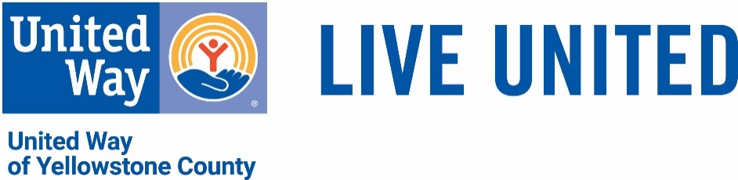

LIVE UNITED Society
Letter of Intent

- Yes! I have included United Way of Yellowstone County in my estate plans.
Name:
Address:
City: State: Zip:
Phone: Email:

Type of Gift:
- Will / Living Trust
- IRA / Retirement Account
- Life Insurance
- Bank, Brokerage or Other Financial Account
- Charitable Trust
- Other (please specify) ________________________________

My future gift to support the LIVE UNITED Society Fund:
- Is a percentage of my estate and is worth approximately $______
- Is the specific amount of $_________________
- I wish to keep the value of my future gift confidential

Donor Recognition choices:
- I / We wish to remain anonymous and do not want this fit acknowledged in public.
- I / We would like to be acknowledged as a member of the LIVE UNITED Society with the following wording:
Name as you would like for it to appear: ___________________________

Signature Date

Please return this form to: United Way of Yellowstone County, 2173 Overland Ave., Billings, MT 59102

